THE RADIO FLYER
  - Monthly News Bulletin of the Iowa City Aero hawks Radio Control Flying Club
  - February 2019 No. 319

CURRENT APPROACH TO AEROHAWK FIELD

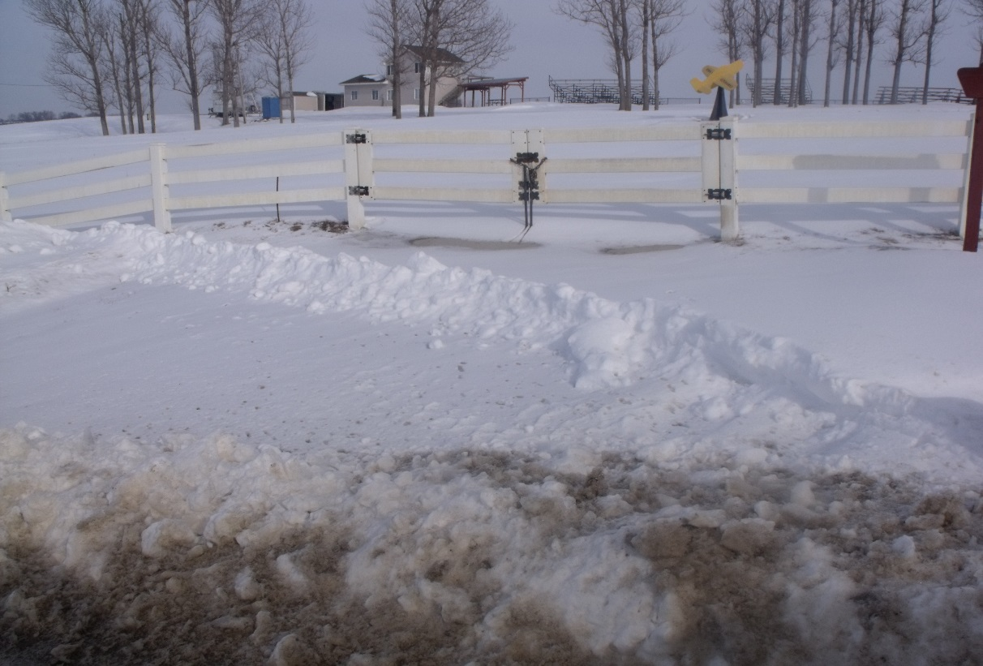

FEB MEETING
The meeting was held on 2/19/19 at the Pizza Ranch in N. Liberty. The 2019 calendar was discussed and agreed upon. Minutes of the meeting and calendar information available at the March 5th meeting 7:00 pm at the Pizza Ranch in N. Liberty.

PICTURE ROSTER COMING
Many of you may have had my camera in your personal space over the last few weeks. Do not despair, there is a reason in my madness. Hopefully, by this July I will be able to publish a roster with personal pictures and contact info for the first time in club history. I have had very positive feed back so far concerning this project and would welcome everyone’s input, positive or negative. A big Thank You to Shirley Dillon for forwarding many photos of club members to me which will help jump start this project.

DUES AND AMA MEMBERSHIP DUE FOR 2019
Consider Paying Your 2019 Aerohawk Dues Online
It is time to think about paying your 2019 Aerohawk membership dues. Dues for active members must be renewed on or prior to our 2019 February general membership meeting. Dues remitted after the February meeting date must include a $10 delinquency fee.
Annual membership dues are $60 and a subsequent family member costs an addition $10. Dues paid by new members joining between September 1 and December 31 of 2018 will cover 2019 as well.
You can submit your dues to the Aerohawks’ Treasurer one of three ways:

- Bring cash or check to a monthly meeting:

2. Mail a check to: Iowa City Aerohawks
PO Box 25
Iowa City, IA 52240
3. Use your online banking BILL PAYER option. Use the PO Box address above to set up Iowa City Aerohawks on your billers’ list. Authorize the dues payment and your bank will mail a check to the Iowa City Aerohawks.

If you have any dues questions, contact Mary Curtis at mary.curtis@mchsi.com.

What to look for in 2019
A lot of exciting events are planned for the coming year. How ‘bout 4 (yeah four) float flies this summer and fall. New members who have not experienced the fun and excitement of flying off water are in for a treat. I will have an article in the March newsletter that explains how to set up your model for floats. Where to place them, how to find the COG and how big (or small) they should be for top performance. Also, plenty of expertise from more experienced club members
We will once again be in the July 4th Coralville parade and have the Airshow again.
2019 Continued:
Mark Niehus has agreed to put together a Fun Fly for later in the summer. Always a high point of the Aerohawk season and open to all club members regardless of skill. (Just need to solo).
A night fly is in the works and is always a lot of fun. We may charge a landing fee this year to off set the cost of the lights.
Of course, the club will be flying mainly on Thursday evenings and Sunday afternoons. Cook outs at the field on those days usually occur.
As you can see, the coming flying season will be full.

Ditch Clean UP
We are fortunate that the IC Landfill has agreed to have us clean the ditches one time this year. We will be walking the roads in April. This is a very important function of the club as it gives us a substantial payday and only takes 2 to 3 hours if everyone pitches in. Plan on keeping that date open for the Aerohawks.

MARCH CALENDAR 2019
MARCH
Mon | Tue | Wed | Thur | Fri | Sat | Sun
 |  |  |  | 1 | 2 | 3
4 | 5 | 6 | 7 | 8 | 9 | 10
11 | 12 | 13 | 14 | 15 | 16 | 17
18 | 19 | 20 | 21 | 22 | 23 | 24
25 | 26 | 27 | 28 | 29 | 30 | 31
Yellow = General Mtg/ Orange = Board Mtg/ Blue = Flying?

