THE RADIO FLYER

  - Monthly News Bulletin of the Iowa City Aero hawks Radio Control Flying Club
  - April 2019 No. 321

Minutes from the April meeting will follow before the meeting Tuesday. They vanished into the dark web or something.

What to look for this month:
A few photos and general information. Calendar for May and June plus dates of upcoming events for the year.

Club meeting at the field this month. May 7th at 7:00 PM.

If a Board meeting is needed it will at the field 7:00 PM on May 21st.

The mowing schedule is posted in the club house. Charlie Bray will call to remind members when they are scheduled to mow. Thank You Charlie, I know I can’t remember that far ahead!

BEHOLD!! LET THERE BE PARKING!!
As you pull into the parking lot at the field in coming days you will notice a vast improvement in the available space. Thanks to all the members that spent an afternoon and evening moving the bleachers out to the north end of the lot. More space now for those with trailers and us other guys with the little planes. See pictures following.
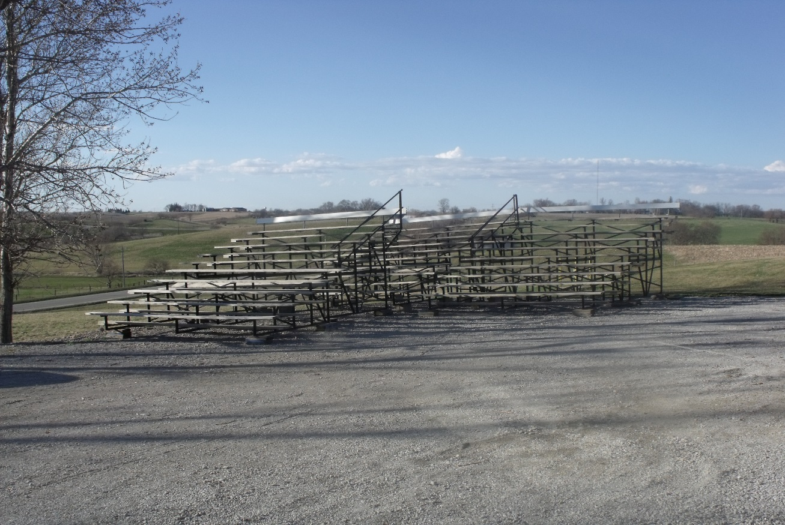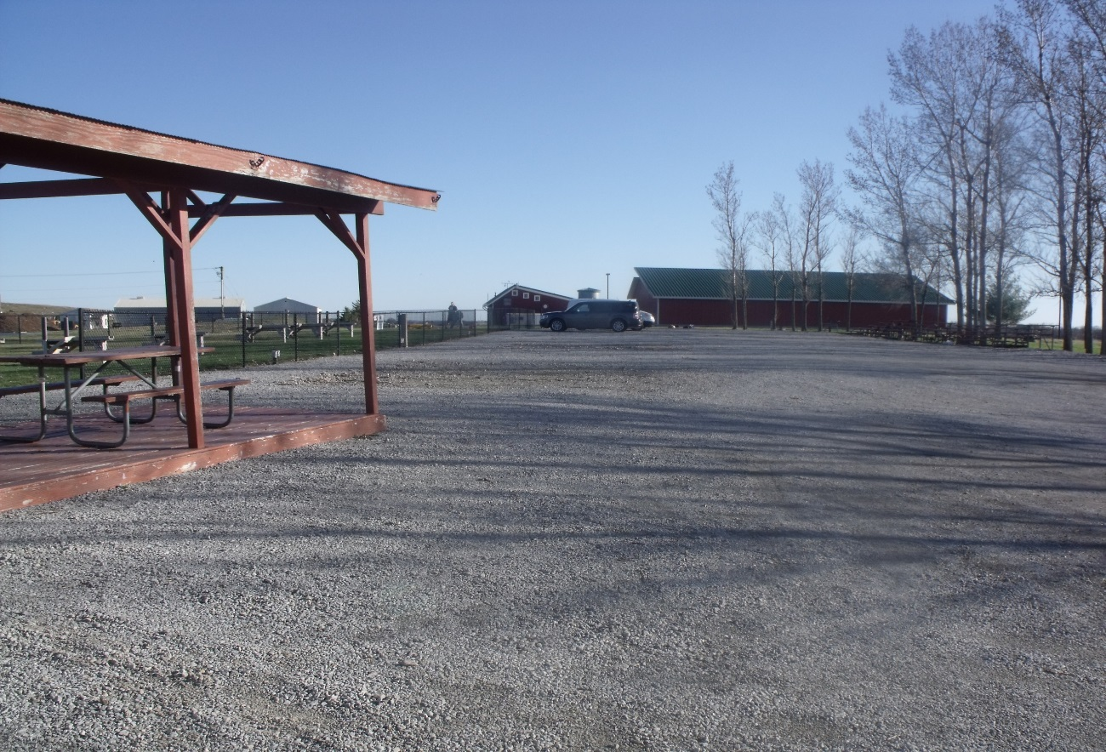

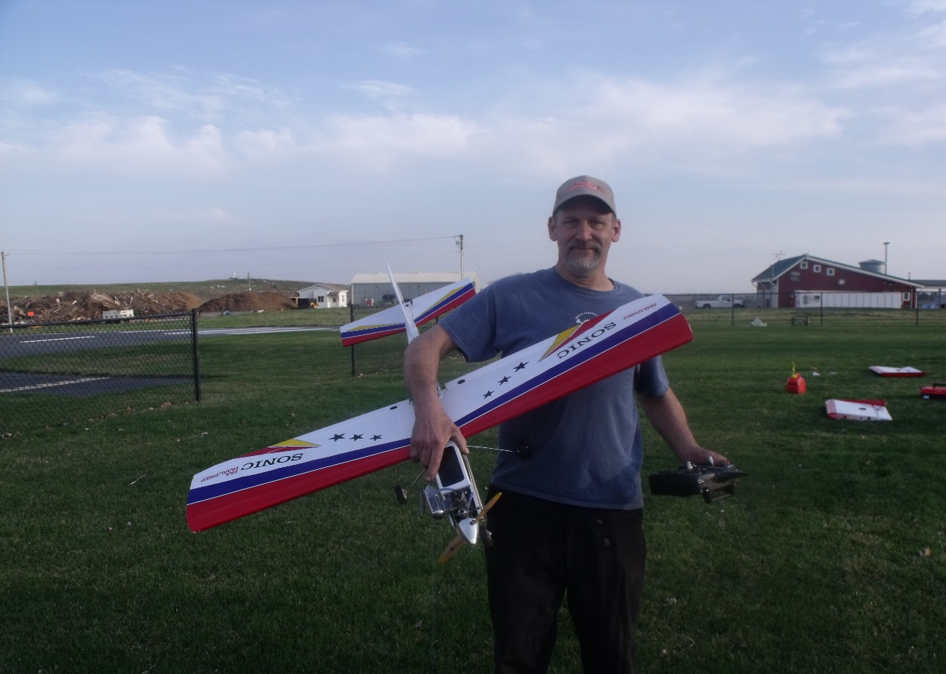
We have a new solo pilot this month!! Congratulations to Eric Roehrle! Eric soloed after several days of weather set backs at the field. Witnessed by Gary Bernabe and Lance Meyer. Way to go Eric. Eric has already been an active member, participating in the last ditch clean-up and helping at the field moving bleachers and signing up for mowing. Introduce yourself to Eric if you haven’t already.

KEEP OFF THE GRASS!
You may have noticed a marked off area where there is new grass popping up. Please wait until it fills in before walking or mowing there. Thanks

Also, need to mention the Pit Area is really looking great this Spring!
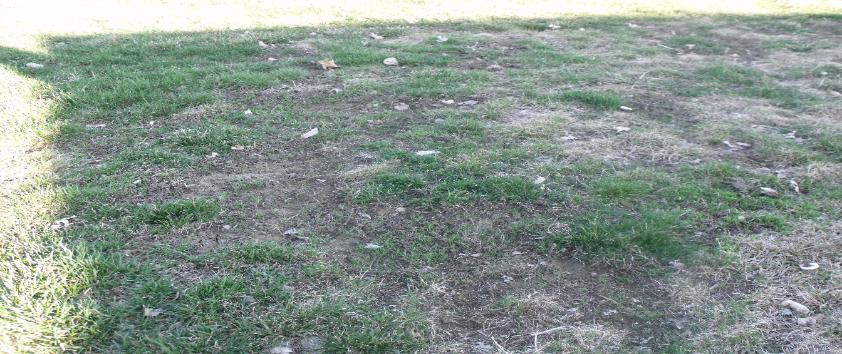
Lance’s grass farm.

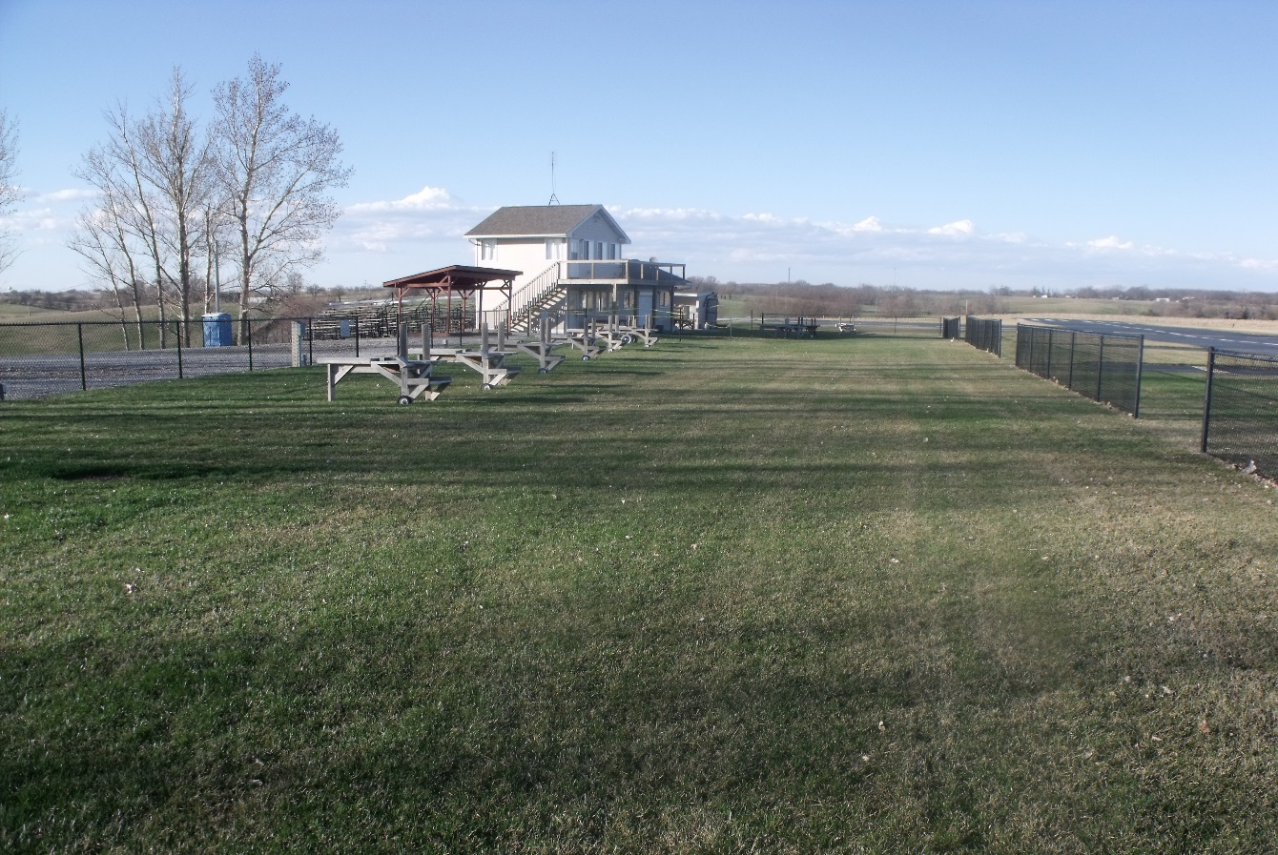
Pit area looking south.

Several new planes at the field this spring. More photos to follow.
Marc Niehus had a very big drop plane to maiden. Flew pretty well even after the aileron servo arm broke completely off. Nice landing Marc.
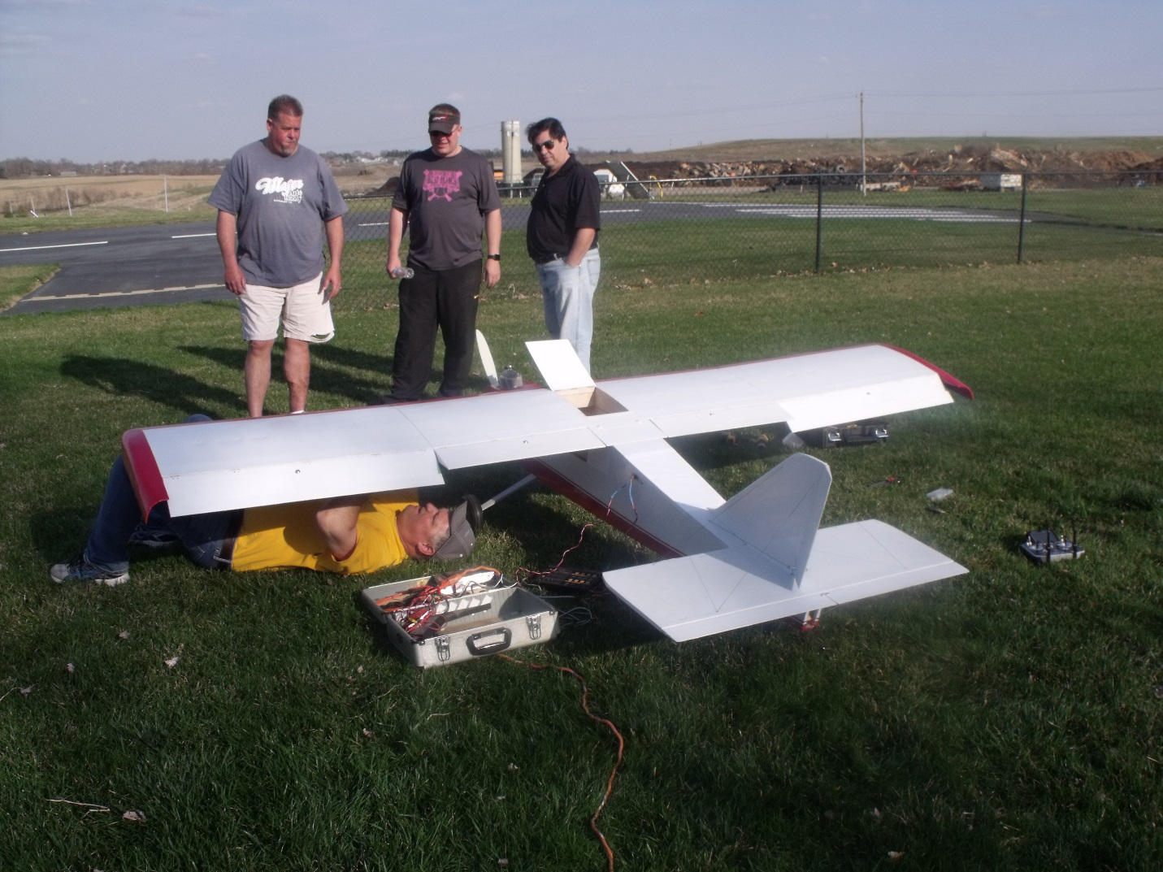

Marc assembling this new monster at the field. Lots of supervision as to how it should be done can be seen.

The Float Plane article I mentioned last month really is too long for the “Flyer”. Lots of good information which I plan to scan and forward to club members this month. Look for it soon.

Calendar for May and June:

May
Mon | Tue | Wed | Thur | Fri | Sat | Sun
 |  | 1 | 2 | 3 | 4 | 5 | YELLOW = MONTHLY MEETING
6 | 7 | 8 | 9 | 10 | 11 | 12 | BLUE = USUAL FLYING ACTIVITY
13 | 14 | 15 | 16 | 17 | 18 | 19 | ORANGE = BOARD MTG IF NEEDED
20 | 21 | 22 | 23 | 24 | 25 | 26 | RED = Blossom Shaw's Memorial 2pm
27 | 28 | 29 | 30 | 31 |  |  | GREEN = cinco de Mayo Walking Tacos
Jun
Mon | Tue | Wed | Thur | Fri | Sat | Sun
 |  |  |  |  | 1 | 2 | YELLOW = MONTHLY MEETING
3 | 4 | 5 | 6 | 7 | 8 | 9 | BLUE = USUAL FLYING ACTIVITY
10 | 11 | 12 | 13 | 14 | 15 | 16 | GREEN = FLOAT FLY RIVERSIDE
17 | 18 | 19 | 20 | 21 | 22 | 23 | ORANGE = BOARD MTG IF NEEDED
24 | 25 | 26 | 27 | 28 | 29 | 30
More Dates for 2019

July 4th = Coralville Parade
July 11th thru 13 = Night Fly at Aerohawk Field
July 27th = 2nd Float Fly at Riverside
August 11 = Aerohawk Annual Airshow
Sept 21st = 3rd Float Fly at Riverside
Oct 13th = Float Fly at Kent Park (Rain Date 20th)
Dec 11th = Annual Holiday Party
2020 Swap Meet Tentative for Jan 25-26th

PHOTO OF THE MONTH
Thank You Rich Vedepo for digging this one up. Wonder who can recognize these handsome flyers?

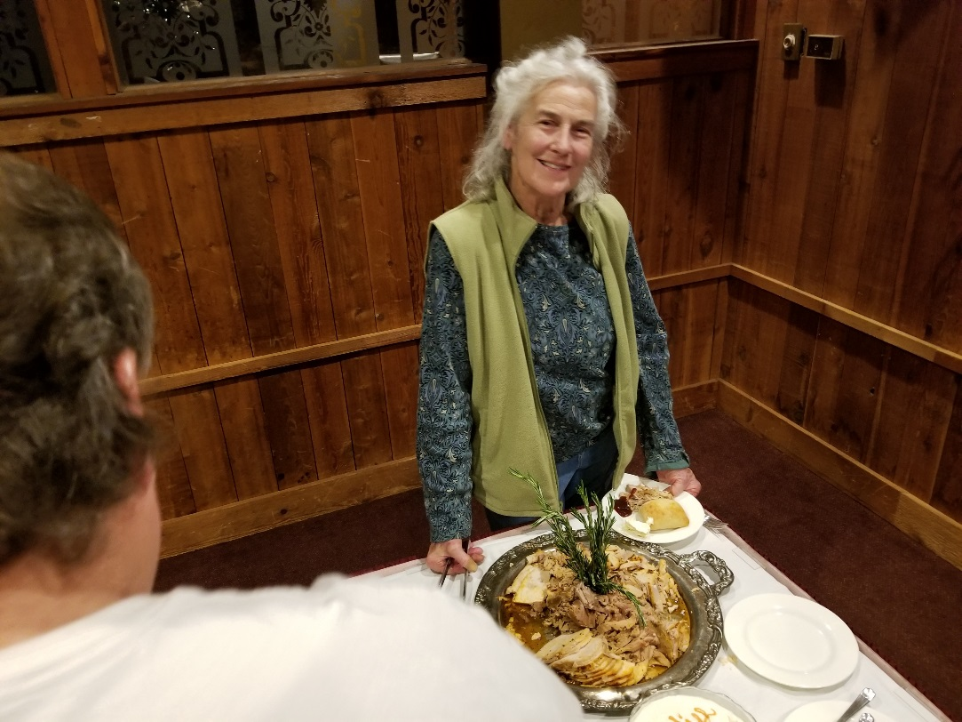

Blossom is with the Angels now and our world is a little bit darker without her smile. Our thoughts and prayers go out to Jay and his family for their loss.
Blossoms Memorial Service will be held at Saint Marks Methodist Church, 2675 E Washington St, Iowa City, IA 52245. Visitation at 1:00 PM. Service to begin at 2:00 PM.

Till next month,
Gary Bernabe
Information Officer

